Change for Change 2019
Support Package

“For I was hungry and you gave me something to eat, I was thirsty and you gave me something to drink, I was a stranger and you invited me in, I needed clothes and you clothed me, I was sick and you looked after me, I was in prison and you came to visit me.” Mathew 25: 35-36

Change for Change Fundraising Campaign 2019
Thank you for joining this exciting mission opportunity. We are thrilled to partner with you in this project. Below you will find all the information you need to host a successful campaign.

What is the Change for Change Fundraising Campaign?

It is the annual campaign that runs from Mother’s Day to Father’s Day where, churches, organizations, or compassionate individuals like you collect their Change to donate to Danica’s Dream Pregnancy Education Center through Servant’s Heart Ministries to provide life Changing education and resources for the babies and their moms of the Dominican Republic.

How do I get my church or organization involved?

Before the campaign:

- Gather baby bottles, mason jars or any container that someone can use to put change into. SHM also has some baby bottles available for use.
- Print off the labels provided in this packet and attach to your containers.
- Print off container tags (also included) to go with each container.

During the campaign:

- Distribute containers to those who want to participate in your church or organization on or around Mother’s Day (May 12, 2019). Keep a record of who has a container so it’s easier at collection time. **remember if you are meeting once a week people can start collecting at any time during the month, so have extra containers for late comers!!!**
- Make an announcement or something creative to remind people of the campaign each week.
Use our video links and stories to help raise awareness.
- Collect the containers along with the tags with the donor’s info on Father’s Day (June 16, 2019)

After the campaign:

- Count the monies in the individual containers and keep a record of it on the container tag. (this will ensure that the donor will receive a tax receipt for their donation)
- Fill out the Record Sheet by hand or similar format on the computer. (If all of the donor’s information is on the Record Sheet a tax receipt can be issued to them by Servant’s Heart Ministries). If a church would prefer to do the receipting themselves, they are free to do so, just let us know with you cheque that the church has taken care of the tracking and receipting.
- Deposit the total monies into your church or organization's bank account.
- Issue a cheque for the total amount to ‘Servant’s Heart Ministries’ and send along with the Donation Record Sheet to:

Servant’s Heart Ministries
211 Pearl Street
Wileville, NS. B4V 5H6

Whoohoo!!!!!! You have just helped more babies have a happy, healthy start to their lives and given their mommas confidence in providing it!!!

Q & A:
Q. Does it have to be done between Mother’s Day and Father’s Day?
A. Absolutely not. While the timing fits well to bring focus to families sometimes it is not the best timing for your church or organization. We have had churches do the same campaign in the fall. They have been equally as successful.

Q. How exactly does this fundraiser change lives?

A. Monies raised from Change for Change goes directly to educating women on both child care and self care. There are many misconceptions in the Dominican Republic on what is safe and healthy for babies. For example breast feeding is largely believed to be an unsafe method of feeding babies.

Q. What if I want to donate, but I do not want to put on a campaign at my church?

A. That’s awesome! You can either send a cheque to Servant’s Heart Ministries at the above address, go online and make a donation with your credit card or call our office at 902-543-2278.

Q. Where can I find videos or other related materials for promoting this campaign?

A. You can email office.admin@servantsheartDR.org and you will receive a link with all sorts of resources, including bulletin inserts, slide for PowerPoint, and more.

Donation Record Sheet
Donor Name | Address | Phone | Email | E News | Amount Collected | Tax Receipt

Servant’s Heart Ministries,
211 Pearl Street
Wileville, NS B4V 5H6

Bottle/Container Tags

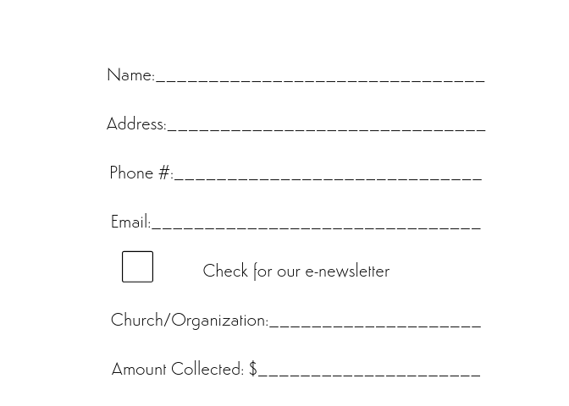

Bottle/Container Labels

